ACTIVITITY-2
Screenshots Steps of hosting task tracker in AWS
Name:Mahathi Kurapati
Email:kurapati.mahathi@gmail.com

Step 1: creation of s3 bucket and static website hosting:
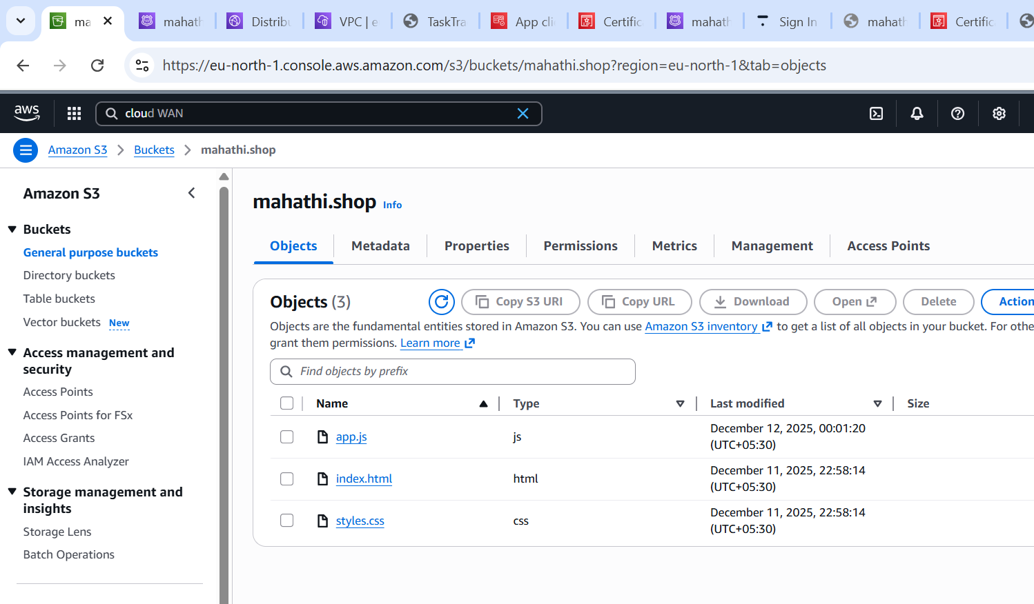
Step 2: link of static website :
http://mahathi.shop.s3-website.eu-north-1.amazonaws.com

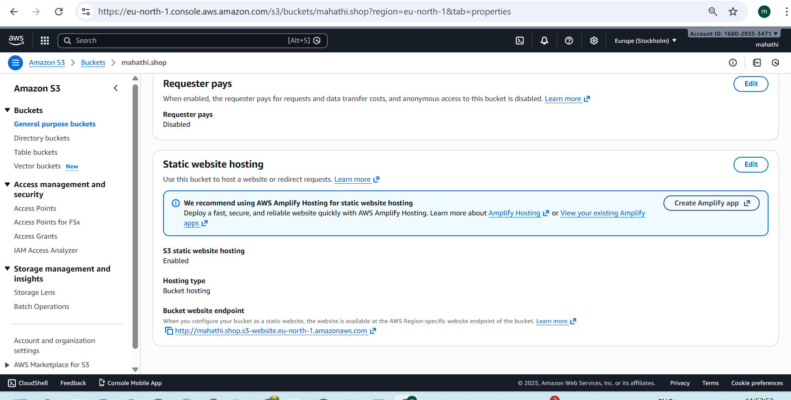
Step 3: AWS Cognito configuration
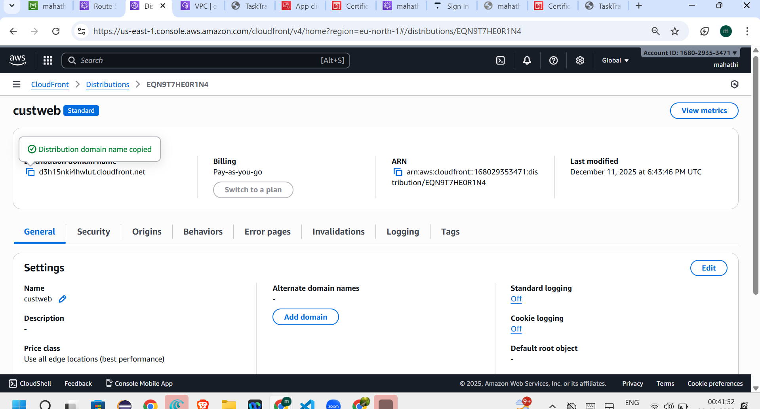
Step 4: final website published on my own domain
